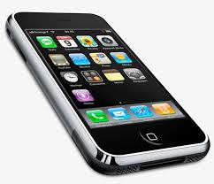

WDMS Cell Phone Policy

**Cell Phone Policy:**

Parents please be aware of District and School policy regarding student possession and use of cell phones:

* Your child may bring a phone to school, but the phone must be kept out of sight. We strongly encourage students to put away their phones in their backpacks, purse, etc., upon arrival on campus.
* The phone must not be allowed to ring or make any sound on school ground.
* No phones in the classroom, hallways or restrooms
* If a student chooses to keep their phone in their pocket and accidentally falls out of the pocket, it will be confiscated.
* Parents who need to reach their child or vice versa must do so through the Guidance Office.
* A student will be given a consequence for violating the cell phone policy.
* The phone will be held in the security office until a parent/guardian picks it up or makes another arrangement.
* Phones can be picked between the hours of 9:30 AM and 3:30 PM

**

William Dandy Middle School will adhere to the District technology policy which states that the use of computers, networks, the Internet and online communication and information systems must be related to students’ educational activities

* Students must recognize that computers, networks, and equipment used to support online learning are shared devices and agree to use them in ways which will maintain their continued operability for all users
* No illegal activity may be conducted using the District’s computers, networks, or online communication and information systems
* Students must not access or distribute offensive, obscene, inflammatory, or pornographic materials, or participate in “sexting” (see Section II for the definition)
* Students shall not intentionally spread, or attempt to spread computer viruses, vandalize data, infiltrate systems, or degrade/disrupt computer and/or network performance
* All users of computers, networks, and online communications and information systems shall adhere to laws regarding copyright.